**Carriage House Wall Cabinet Assembly Instructions**

**BEFORE ASSEMBLING:**

* Carefully read the instructions before starting the installation.
* Empty the carton completely to make sure all pieces are removed, and nothing is discarded.

**NOTE:** Once the glue dries, it is the glue that holds the cabinet together. The assembly clips (plastic and metal) supplied are for holding the cabinet together until the glue dries.

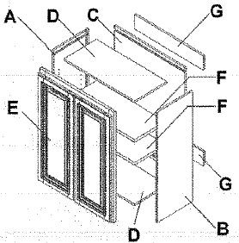

Parts Overview & List

1. Side panel (left)
2. Side panel (right)
3. Back panel
4. Panel (top & bottom)
5. Face frame & doors
6. Shelf

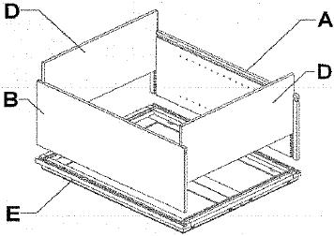Steps 1-5: Box Assembly

1. Lay cabinet face frame (E) on a clean/soft surface.

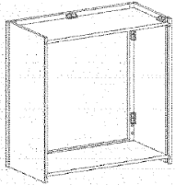

1. Apply a light bead of glue into the dado of the face frame (E) where the top side panels (A&B) will be installed.
2. Place the side panels (A&B) firmly into the dadoes.
3. Block/Clip placement
   1. Plastic block assembly

Clip Placement

Clips will be placed on the left and right sides of the inside of the cabinet.

* + 1. Place the plastic assembly blocks as indicated in the diagram.
    2. Place two staples into the plastic assembly blocks on each side, attaching it to the face frame and side panels.
  1. Metal clips assembly
     1. Screw the “L-shaped” metal clip into the predrilled spots along the frame of the cabinet.
     2. 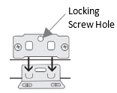Screw the “flat” metal clip into the predrilled spots on the side panels.
     3. Slide each side panel into dado, making sure bottoms are perfectly alligned.
     4. Once in place, attach the sides of the frame using the clips previously installed.
     5. Fasten clips together using provided screw in the locking screw hole.

1. Apply a light bead of glue to the face frame (E) and the side panels (A&B) where the top and bottom panels (D) install. Slide the top and bottom panels (D) into place.

Steps 6-8: Back Attachment

1. Apply a light bead of glue into dadoes that will fit the back panel (C).
2. Install the back panel (C) by spreading lightly the side panels (A&B) just enough to fit the back panel into the dadoes.

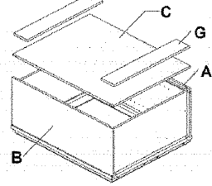

1. Screw the back panel to the sides using the pre-drilled holes provided screws.

Step 9: Shelf Placement

1. Insert shelf clip into the holes on the side panels (A&B). Make sure each clip is the same height as the corresponding clips. Each shelf requires 4 clips.
   1. 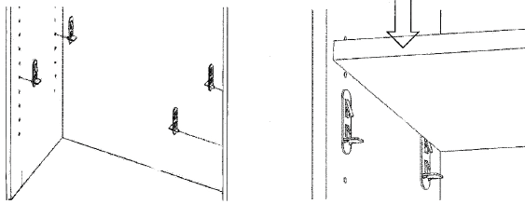Cabinets 21” or less in height will have no shelf.
   2. Cabinet 24” – 36” in height will have two shelves.
   3. Cabinets 42” in height will have 3 shelves.
   4. Pantry cabinets will have 4 shelves.

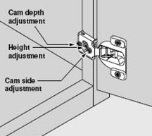Step 10-11: Hinge & Bumper Placement

1. Place the door face down, install the hinges, and extend the hinge to the open position. With the hinges in the extended position, attach the door to the face frame of the cabinet. The door can be adjusted using the adjustment screws if necessary.
2. Attach the bumpers to the outside corners of the doors and the top corners of the drawers.